Talk to us

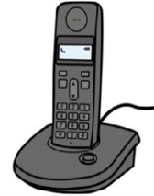
Call 9286 1000
1800 451 524
Email nswombo@ombo.nsw.gov.au

Website www.ombo.nsw.gov.au
ISBN: 978-1-925885-85-9
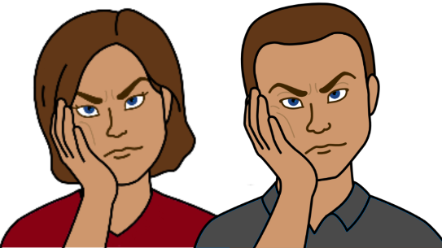
There is a problem.
You are not happy with a
- NSW government service
- NSW community service.
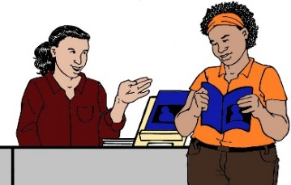
You ask for help from a service
Like you want
- more information
- to know how to use their service
- to make a complaint.
But
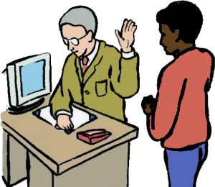
You did not get the help you need. Like
- staff were rude to you.
- did not listen to you
- did not respect you.
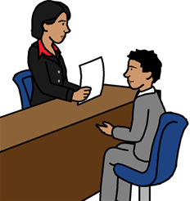
You tell the service about
your problem.

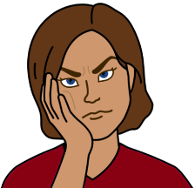
But
It did not help.
You still have the problem.

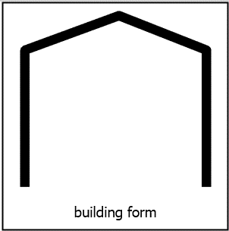
The NSW Ombudsman may be able to help you. Our service is free.

