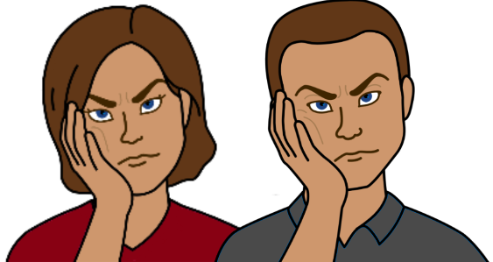

There is a problem.
How to make a complaint.

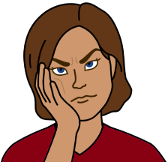
There is a problem.
You are not happy with a
- NSW government service
- NSW community service.

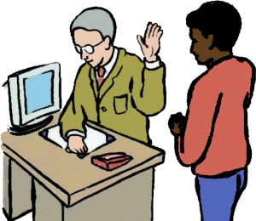
Like staff
- did not listen to you
- did not respect you

- talked to you in a way you
can not understand.

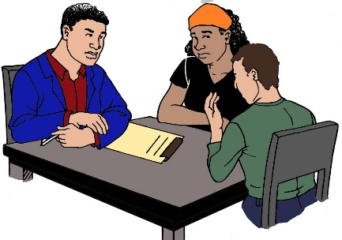
- did not give you time to talk
- talked to your support person only.

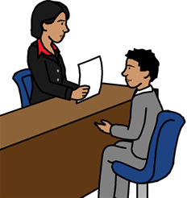
You tell the service about your problem.

But
You still have the problem.
You are not happy.

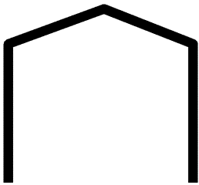
We may be able to help you.
We are the NSW Ombudsman.

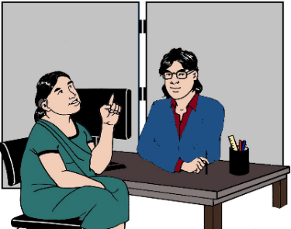
You tell us your problem.
We call it a complaint.

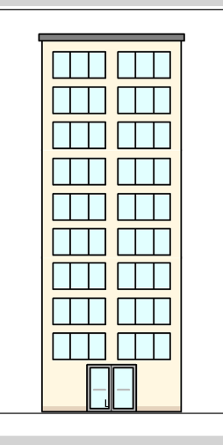
It is about a NSW government service. Like
- your school
- Transport NSW. It may be about
- your bus
- the train
- your Opal card
- Service NSW.

Or

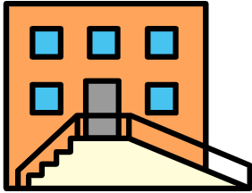
It is about a NSW community service. Like
- someone who helps when you do not have a home
- a boarding house
- someone who helps when a child can not live at their home

We can not help you all the time.

You are not sure we can help you.
That is OK.
You can ask us.
We may not be able to help you.

But

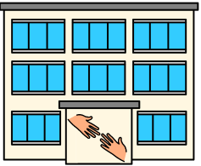

We will tell you where you can go for help.

Who can make a complaint?

You can make a complaint.

Or

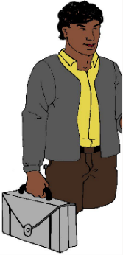
You can ask some one else to do the complaint.
Like
- a person from your family
- a carer
- person you trust.

The NSW Ombudsman may ask you to sign

a letter. We need to know you are OK with this.

It means yes.
Some one else can do the complaint for you.
You are OK with this.

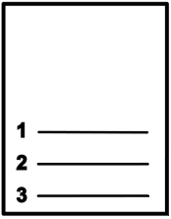
How do you make a complaint?

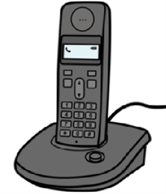
Call 1800 451 524.
Talk about your problem.
Work out the next steps.

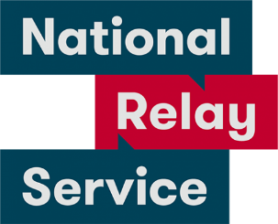
National Relay Service
Call 1800 555 677.
Ask them to call 1800 451 524.

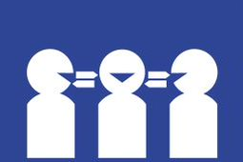
Translator.
Call 131 450.
Ask them to call 1800 451 524.
or

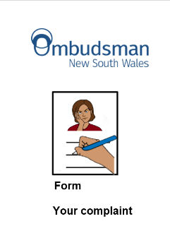
Ask for the Complaints form.
Ask for the Easy English form.

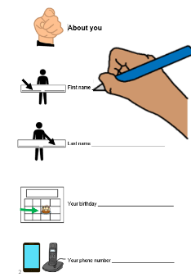

Do the questions.

Send to
NSW Ombudsman
Level 24, 580 George street
Sydney NSW 2000

What do we do?

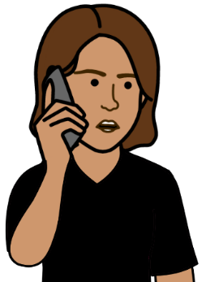
We listen to you.

We can help you.
We talk about you can do.
You know how to fix the problem now.

The phone call fixes the problem.

Or

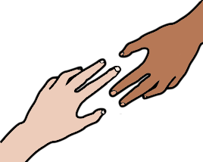
We can help you.

But
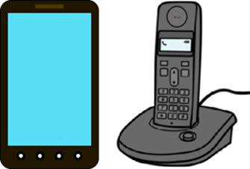

We can not fix it over the phone.

We will write to you
It says
- we have your form
- what we will do next.

We look at your problem. We may talk to
- you
- the service
- other people you have asked to help you

We tell you
- what we can do to fix the problem

or

- we can not fix the problem.

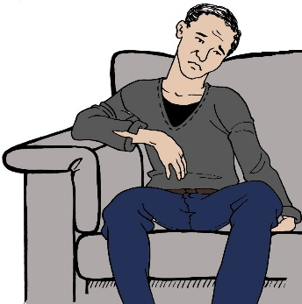
It may take a long time to work out what to do.
We will tell you what we are doing. We will
- call you
or
- write to you.

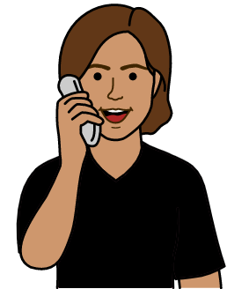

You do not need to call us.

Some times you work out the problem.
You do not need our help now. That is OK.
Tell us. We will stop our work too.

More information

Call 1800 451 524

Do the Form. Your complaint.

or

Go to www.ombo.nsw.gov.au
Look for Easy English on the home page.
Images
We have used images from
- ChangePeople
- Inspired Services
- Picto-Selector
- TheNounProject
- Tobii-Dynavox

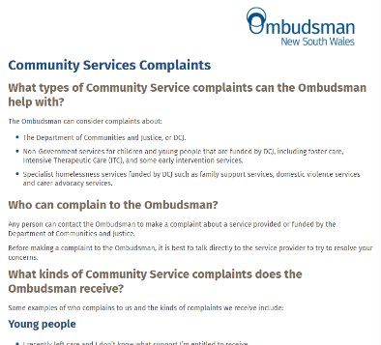
This fact sheet is based on the
NSW Ombudsman Community Services Complaints fact sheet.
Date 14 January 2020.

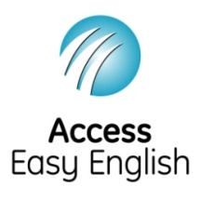
Access Easy English wrote the Easy English.
July 2021.
ISBN: 978-1-925885-84-2

